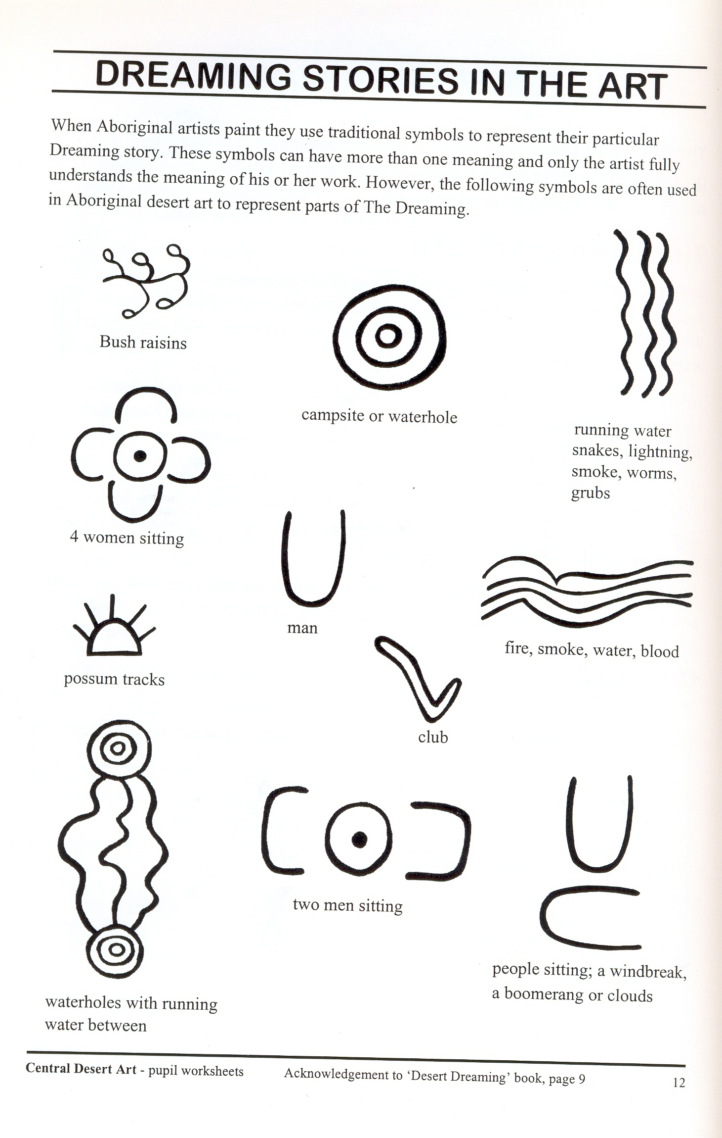
Symbols in Aboriginal Art BLM

These sheets are examples of Indigenous art symbols. They are copied from the Peter Leyden visual teaching resource Central Desert Art which includes: 12 posters of Central Desert art; pupil books Growing Up At Uluru; a book, Desert Dreaming, and a book of worksheets. Purchase the resource and the worksheets are photocopiable for student use.

Please note: Out of respect for people of the desert Country to whom concentric circles and squares are sacred, students must not combine these two symbols with the sacred ochre colours.

